
STRATEGIC EMPLOYEE ATTRITION INTELLIGENCE
Employee Attrition Analytics and Workforce Insights

FINAL PROJECT REPORT

AI Specialist — Data Analyst Track
Prepared by: N.varalakshmi
Date: 21 September 2026

Table of Contents
1. Introduction
2. Project Initialization and Planning Phase
3. Data Collection and Preprocessing Phase
4. Data Visualization
5. Dashboard
6. Report
7. Performance Testing
8. Conclusion/Observation
9. Future Scope
10. Appendix

Final Project Report

Strategic Employee Attrition Intelligence Dashboard

Executive Summary
This project analyzes employee attrition using a dataset of 5,000 employee records and 29 attributes. The dataset contains 895 employees who left the organization and 4,105 who remained, giving an overall attrition rate of 17.9%. The project uses SQL for data exploration and validation and Power BI for data preparation, KPI creation, interactive visualization, and dashboard reporting. The analysis focuses on department, job role, work mode, compensation, tenure, workload, employee wellbeing, and AI-related indicators to help users explore patterns associated with employee attrition.

1. Introduction

1.1. Project Overview
The Strategic Employee Attrition Intelligence Dashboard is a business analytics project designed to transform employee data into clear and interactive workforce insights. The source dataset contains 5,000 employee records with demographic, organizational, compensation, workload, wellbeing, performance and AI-related attributes. SQL was used for initial exploration and validation, while Power BI was used to clean, model, measure and visualize the data.

1.2. Objectives
- Understand the overall level and distribution of employee attrition.
- Compare attrition across departments and job roles.
- Examine work mode and workload patterns associated with attrition.
- Analyze compensation, tenure, engagement, burnout and work-life-balance indicators.
- Explore AI-tool adoption and perceived AI job risk in relation to attrition.
- Build an interactive Power BI dashboard with KPI cards, charts and filters for business users.

2. Project Initialization and Planning Phase

2.1. Define Problem Statement
PS | I am (Customer) | I’m trying to | But | Because | Which makes me feel
PS-1 | An HR manager or workforce analyst | identify where employee attrition is occurring and understand related workforce patterns | employee information is spread across many fields and is difficult to compare from raw records | the dataset needs aggregation, filtering and visualization before useful patterns become clear | uncertain about which employee groups require closer retention analysis
PS-2 | A business manager responsible for workforce planning | monitor attrition indicators and compare factors such as department, role, workload, wellbeing and AI-related risk | traditional tables do not provide a quick interactive view of these comparisons | different employee characteristics need to be analyzed together | concerned that important retention patterns may be missed

2.2. Project Proposal (Proposed Solution)
The proposed solution is an interactive Power BI dashboard that converts the employee attrition dataset into understandable KPIs and visual insights. SQL is used for data exploration and validation, Power Query is used for data preparation, and Power BI measures and visuals are used to analyze attrition by department, job role, work mode and other employee factors.

2.3. Initial Project Planning
The project workflow is organized into three practical stages: data preparation and SQL analysis, Power BI visualization and dashboard development, and validation/report documentation.
Sprint | Main Activities | Key Output
Sprint 1 | Data collection, SQL exploration, quality checks, field and data-type review | Prepared dataset and validated analytical fields
Sprint 2 | Power Query transformation, data modeling, KPI/DAX measures and visual development | Working Power BI report and analytical visuals
Sprint 3 | Dashboard refinement, filters, validation, observations and documentation | Final dashboard and project report

3. Data Collection and Preprocessing Phase

3.1. Data Collection Plan and Raw Data Sources Identified
The primary data source is the employee attrition CSV dataset, containing 5,000 rows and 29 columns. It includes employee identifiers, demographics, department and role information, income and career variables, work conditions, wellbeing measures, performance indicators, AI-tool usage and attrition status. The SQL file was used to inspect the data and perform group-level checks before Power BI analysis.

3.2. Data Overview
The dataset contains 5,000 employee records and 29 attributes. It covers department, job role, job level, monthly income, work mode, overtime, years at company, manager support, burnout, engagement, work-life balance, performance, AI adoption and perceived AI job risk. There are {int(df.isna().sum().sum())} missing values in the supplied dataset.

3.3. Data Cleaning
The dataset was checked for missing values, duplicate records, data types and consistency of categorical and numerical fields. Numeric fields were retained as numeric values, categorical fields were reviewed for consistent labels, and the data was prepared for Power BI analysis. The supplied dataset contains no missing values.

3.4. Data Transformation and Preparation
- Verified and corrected data types for numerical, categorical and Boolean fields.
- Reviewed employee, department, job role, work mode and attrition fields for consistent analysis.
- Used filtering and grouping to support department, role and work-mode comparisons.
- Prepared measures for total employees, attrition count, attrition rate and average workforce indicators.
- Prepared the cleaned dataset for Power BI modeling and visualization.

3.5. SQL Exploration and Validation
The supplied SQL file contains queries for overall row counts, department-level attrition, wellbeing averages, missing-value checks, workload by work mode and sample-record inspection.
Analysis | Purpose
Employee count | Confirm the size of the source dataset.
Department-level attrition | Compare employee totals and attrition counts by department.
Baseline wellbeing averages | Review burnout, engagement and work-life-balance scores.
Null/missing-value check | Verify completeness of important fields.
Workload by work mode | Compare average overtime hours across work modes.

4. Data Visualization

4.1. Framing Business Questions
- What is the total number of employees and the overall attrition rate?
- How does attrition vary across departments?
- Which job roles show different levels of employee attrition?
- How does attrition vary across work modes?
- How does employee attrition compare with overtime workload?
- How do engagement, burnout and work-life-balance scores differ by attrition status?
- How does monthly income compare between employees who stayed and those who left?
- Is AI-tool adoption associated with a difference in employee attrition?
- How does perceived AI job risk differ between attrition groups?
- How does employee tenure relate to attrition?

4.2. Developing Visualizations
Chart Type | Fields / Measures | Purpose
KPI Cards | Total Employees, Attrition Count, Attrition Rate, Avg Monthly Income, Avg Years at Company | Summarize key workforce indicators
Bar/Column Chart | Department, Attrition Count/Rate | Compare attrition across departments
Bar/Column Chart | Job Role, Attrition Count/Rate | Compare attrition across roles
Donut Chart | Attrition status | Show the proportion of employees who stayed and left
Bar/Column Chart | Work Mode, Attrition Rate | Compare work-mode attrition patterns
Line/Column Visual | Relevant employee grouping with attrition measure | Show variation in attrition across an ordered employee dimension
AI Usage Visual | AI adoption, Attrition measure | Explore AI-tool usage and attrition
KPI/Comparison Visual | Workload and wellbeing measures | Compare employee conditions by attrition status

5. Dashboard
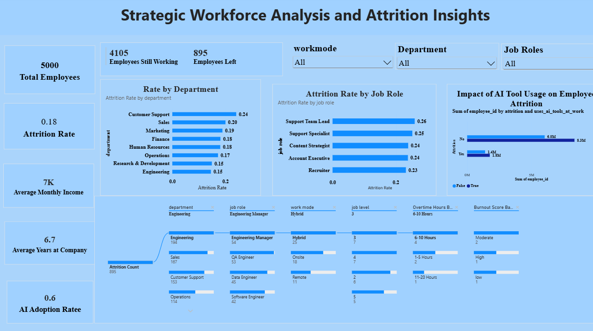

5.1. Dashboard Design and Key Insights
The dashboard brings the main employee attrition indicators into a single interactive view. KPI cards provide an immediate summary, while department, job-role, work-mode and AI-related visuals allow users to explore differences across employee groups.
Key descriptive figures from the supplied dataset:
- Total Employees: 5,000
- Employees with Attrition: 895
- Employees Still Working: 4,105
- Attrition Rate: 17.9%
- Average Monthly Income: ₹6,991
- Average Years at Company: 6.7
- AI Tool Adoption: 57.3%
Dashboard visual interpretation should be treated as descriptive analysis of this dataset; it does not establish that any single factor causes attrition.

6. Report
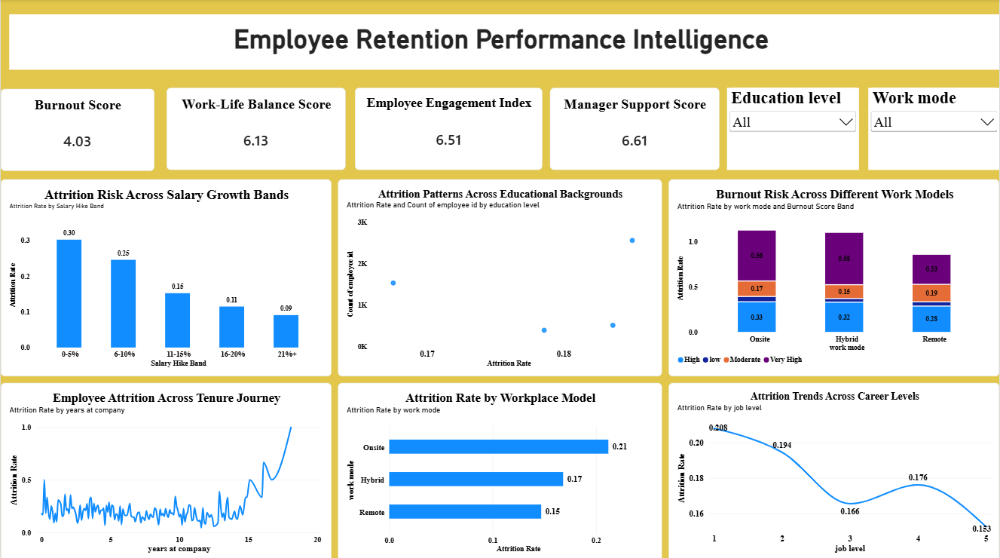

6.1. Report Design with Insights
The following observations are calculated directly from the supplied dataset:
- Department attrition rates range from 14.5% to 24.1% across the eight departments.
- Customer Support has the highest department-level attrition rate in this dataset at 24.1%, while Engineering is at 14.5%.
- Work-mode attrition rates are 21.2% for Onsite, 16.8% for Hybrid and 14.7% for Remote.
- Employees marked Yes for attrition have lower average monthly income (₹6,675) than employees marked No (₹7,060).
- Average overtime is 8.8 hours/week for employees with attrition versus 6.4 hours/week for employees without attrition.
- Average manager-support score is 5.7 for the attrition group versus 6.8 for the non-attrition group.
- AI-tool adoption is 57.3% overall; the attrition rate is 17.3% among adopters and 18.6% among non-adopters.
- 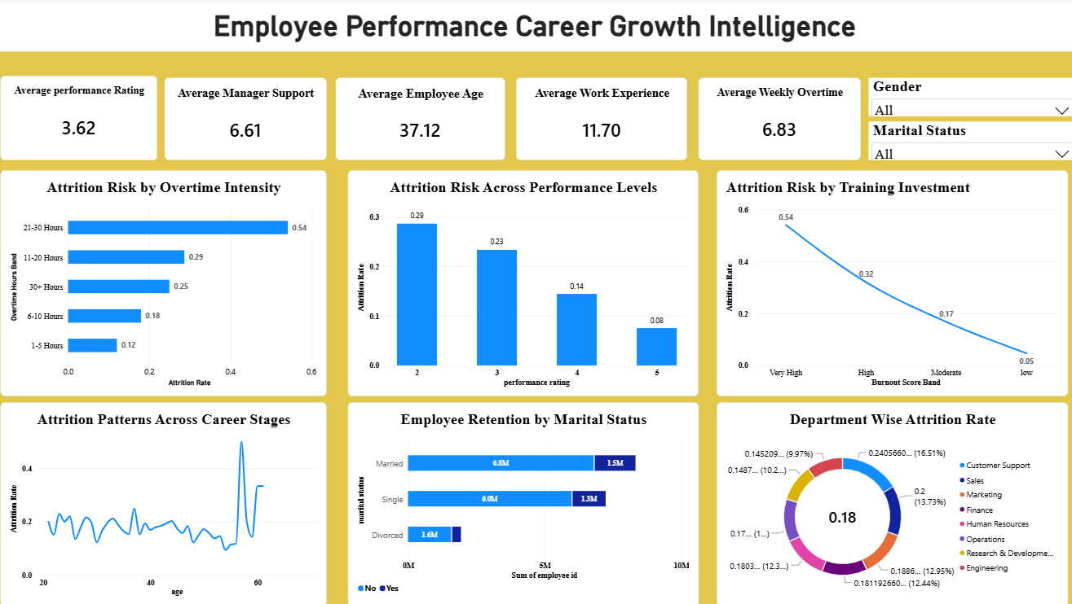

6.2. Department-Level Analysis
Department | Employees | Attrition Count | Attrition Rate
Customer Support | 636 | 153 | 24.06%
Engineering | 1336 | 194 | 14.52%
Finance | 436 | 79 | 18.12%
Human Resources | 244 | 44 | 18.03%
Marketing | 440 | 83 | 18.86%
Operations | 663 | 114 | 17.19%
Research & Development | 410 | 61 | 14.88%
Sales | 835 | 167 | 20.00%

6.3. Work-Mode Analysis
Work Mode | Employees | Attrition Count | Attrition Rate
Hybrid | 2237 | 376 | 16.81%
Onsite | 1742 | 369 | 21.18%
Remote | 1021 | 150 | 14.69%

6.4. Key Employee Indicators by Attrition Status
Indicator | Attrition = Yes | Attrition = No
Monthly Income | ₹6,675 | ₹7,060
Years at Company | 6.47 | 6.78
Overtime Hours/Week | 8.77 | 6.40
Manager Support | 5.69 | 6.81
Burnout Score | 5.06 | 3.81
Engagement Score | 5.54 | 6.72
Work-Life Balance | 5.57 | 6.25
Salary Hike % | 10.50 | 11.74
Perceived AI Job Risk | 5.23 | 4.77

7. Performance Testing

7.1. Utilization of Data Filters
The Power BI dashboard can be tested by selecting different employee dimensions and checking whether connected visuals update consistently. Recommended filters include department, job role, work mode, attrition status and AI-related fields where present in the report.

7.2. Calculation Columns and Measures
The project uses calculated measures/KPIs for employee totals, attrition count, attrition rate and average workforce indicators. The exact number of DAX measures should be recorded from the final PBIX model before submission if the academic template requires a fixed count.

7.3. Number and Types of Visualizations
The dashboard/report uses KPI cards and comparative Power BI visuals such as bar/column charts, a donut chart and additional analytical visuals developed for department, job-role, work-mode and AI-related analysis. The exact final visual count should be taken from the submitted PBIX report pages.

8. Conclusion / Observation
The analysis of 5,000 employee records shows an overall attrition rate of 17.9%. Attrition differs across departments, job roles and work modes, indicating that employee turnover is not evenly distributed across the workforce. The descriptive comparisons also show differences in income, overtime, manager support, burnout, engagement and work-life-balance scores between employees with and without recorded attrition. AI-tool adoption and perceived AI job risk provide additional dimensions for workforce analysis.
These findings are descriptive associations within the supplied dataset. They should be used to identify areas for further investigation rather than to claim that a particular factor independently causes employee attrition.

9. Future Scope
- Add historical employee records to analyze attrition trends over time.
- Develop drill-down and drill-through pages for department, job role and employee segments.
- Add predictive analytics or machine-learning models to estimate attrition risk, with appropriate validation.
- Introduce additional HR variables such as promotion history, exit reasons and employee feedback where available.
- Create a mobile-responsive Power BI layout for easier access.
- Automate data refresh and dashboard distribution for regular workforce monitoring.

10. Appendix

10.1. Source Code / Queries
The supplied employee_attrition.sql file includes SQL statements for database selection, record counts, department-level attrition, wellbeing averages, null checks, workload comparisons by work mode and sample data inspection.

10.2. Project Files
- employee_attrition(1).csv — source employee dataset
- employee_attrition.sql — SQL exploration and validation queries
- mila30.pbix — Power BI dashboard/report file

10.3. GitHub & Project Demo Link
GitHub Repository: https://github.com/varalakshmi2128/Stategic-Employee-Attrition-Intelligence-Dashboard
Project Demo Video: https://github.com/varalakshmi2128/Stategic-Employee-Attrition-Intelligence-Dashboard/blob/main/7.Project%20documentaion%20%26%20demonstration/Demonstration.mp4

